Inertia and Momentum

Recall Newton’s first law of Motion…
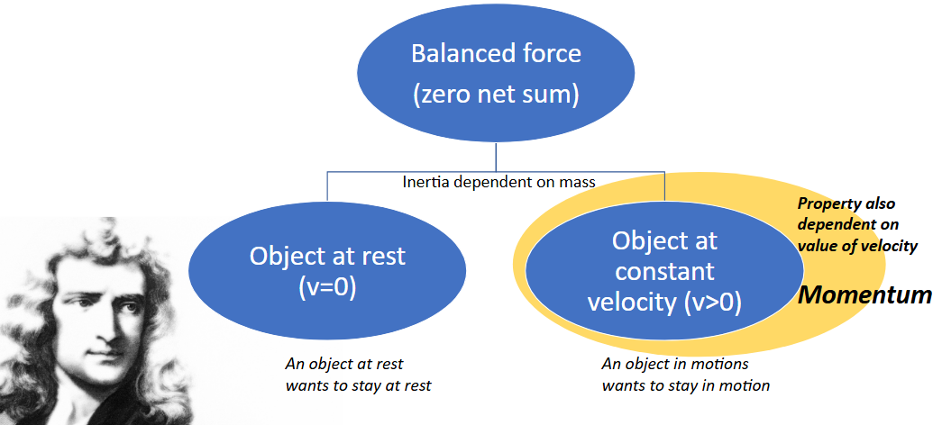

Compare the inertia and momentum of the truck and cart below…

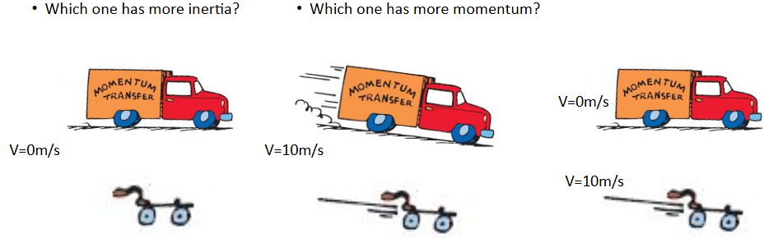

Momentum is inertia in motion and is based on mass and velocity

A basketball is thrown and continues in motion. What allows it to continue in motion?

Which is most difficult to stop? Why?
- Basketball at 2 m/s c) tennis ball at 2 m/s
- Basketball at 4 m/s d tennis ball at 4 m/s

s
Calculating Momentum

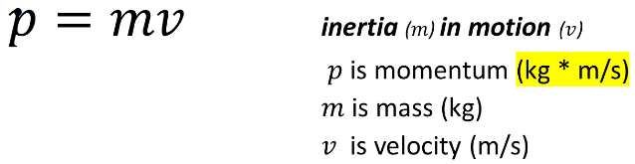

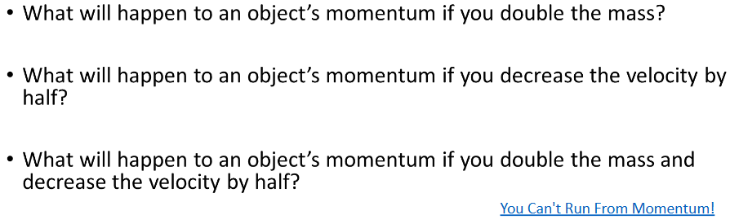

Ex1: An 80 kg football player is moving at 5 m/s. Calculate his momentum.

Change in Momentum

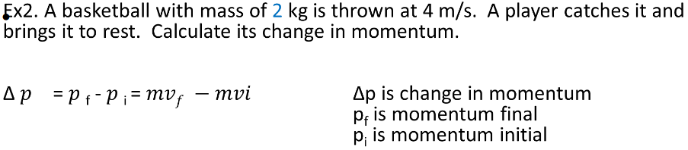

Calculating Impulse
Impulse is force x time
J = Ft J is impulse with units: N*s OR kg*m/s
F is force with units: Newtons (N) or kg*m/s²
t is time with units: seconds (s)
- If impulse remains constant, what happens to the force when you triple the stopping time?
- If impulse remains constant, what happens to the stopping time when you double the force of the impact?

Impulse, Force, and Stopping Time
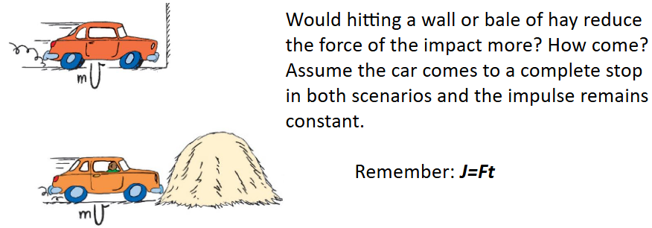
Calculate Force for each Scenario
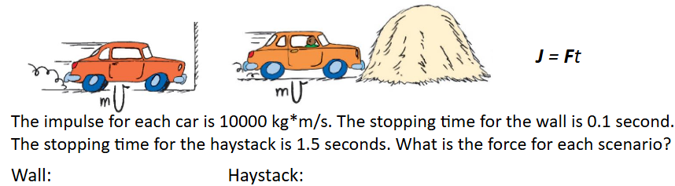

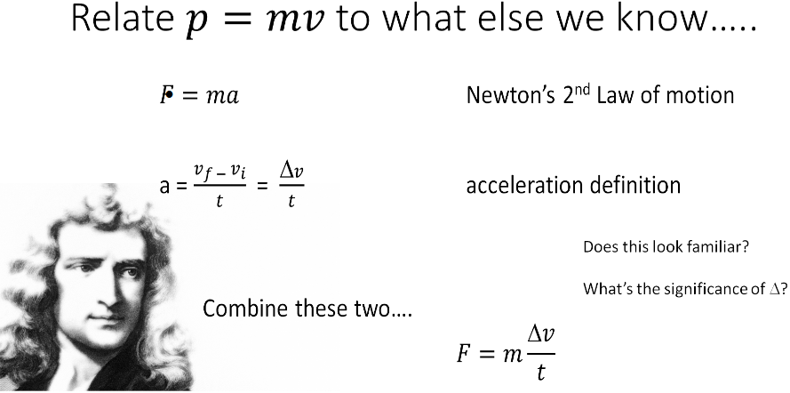

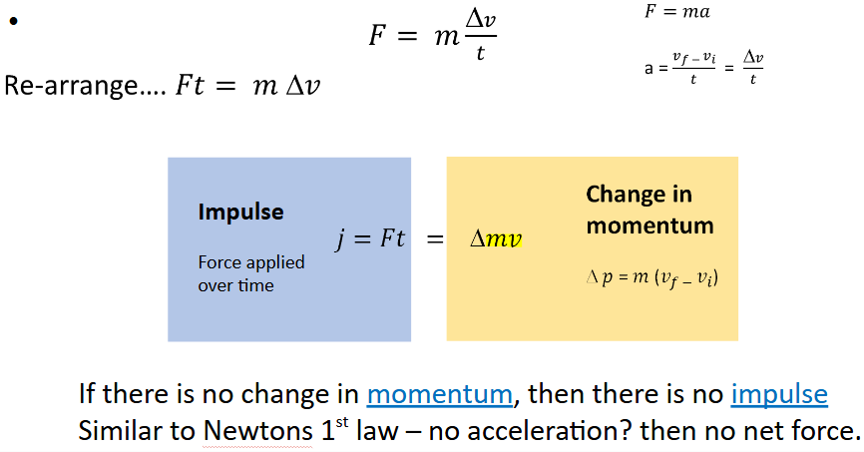
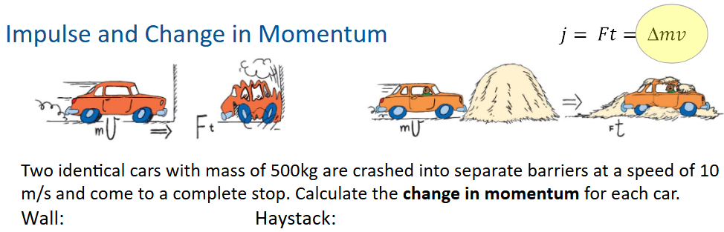

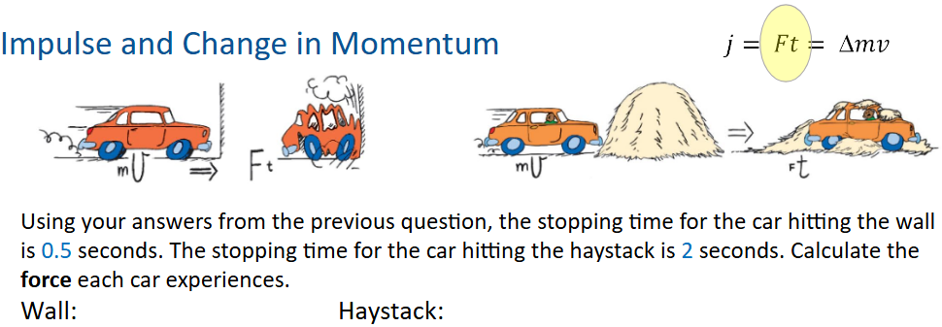

Problem-solving:
Impulse: J = F*∆t (Impulse = Force* time),

Impulse-Momentum Theorem: F*∆t = ∆p, or F*∆t = $mv_{f}-mv_{i}$
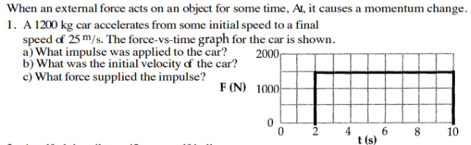

2.

Practice Problems
Introduction to Momentum
P = mV (Momentum=mass*Velocity)
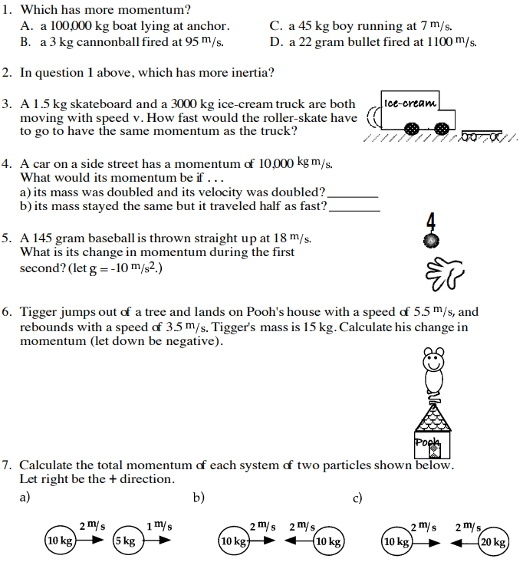

Impulse
J = F*∆t (Impulse = Force* time),

Impulse-Momentum Theorem: F*∆t = ∆p, or F*∆t = $mv_{f}-mv_{i}$
